A REPORT
ON
EXTENSION ACTIVITIES
NAGAON GNDG COMMERCE COLLEGE
PERIOD:2021 – 2022

1.NAME OF ACTIVITY: Tree Plantation Programme
2. VENUE : Village Karaiyani
3.DATE : 28th February 2022
4.A BRIEF REPORT The NSS unit of Nagaon GnDg Commerce College undertook a tree plantation programme at Karaiani village on 28th February 2022 .The village is an adopted village of the institution and we attempt to undertake beneficial projects for the villagers living there.
5.Number of VOLUNTEERS PRESENT15
6.TEACHERS PRESENT 4
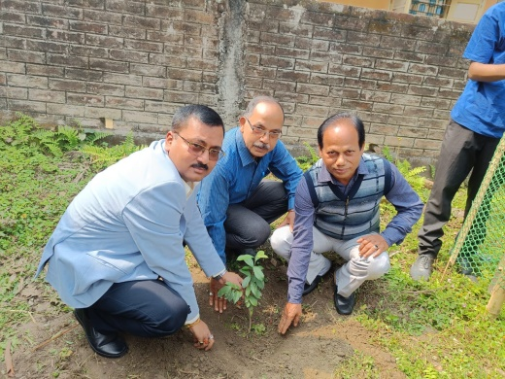
7.NUMBE OF BENEFICIARIES The villagers of that area.

