A REPORT
ON
EXTENSION ACTIVITIES
NAGAON GNDG COMMERCE COLLEGE
PERIOD:2021 – 2022

1.NAME OF ACTIVITY Booster Dose Camp for Covid Vaccination
2. VENUE : College Auditorium
3. DATE ,2022
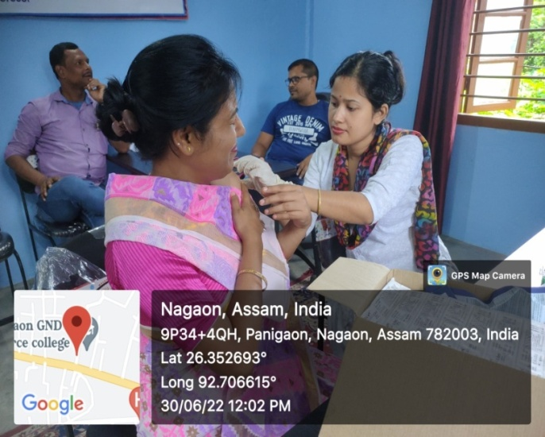
4. A BRIEF REPORT .The Government Health department organized a booster dose camp for Covid vaccination in the college complex. A large number of people from the nearbty locality benefitted from the camp.
5.Number of VOLUNTEERS PRESENT 15.
6.TEACHERS PRESENT 10
7.NUMBE OF BENEFICIARIES .
PHOTOGRAPHS
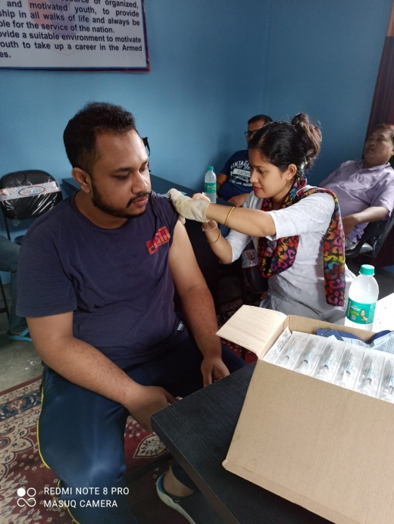
MEDIA COVERAGE

