A REPORT
ON
EXTENSION ACTIVITIES
NAGAON GNDG COMMERCE COLLEGE
PERIOD:2021 – 2022

1.NAME OF ACTIVITY Flood Relief Distribution
2. VENUE :Gandhibori Village, Morigaon
3. DATE 29th June ,2022
4. A BRIEF REPORT During the unprecedented floods in the month of May/June the college community joined hands to relieve those in distress and a group 0of volunteers including teachers and students visited theGandhibori village in Morigaon district and distributed relief in the form of water bottles, food packets and medicine to the flood inflicted people.
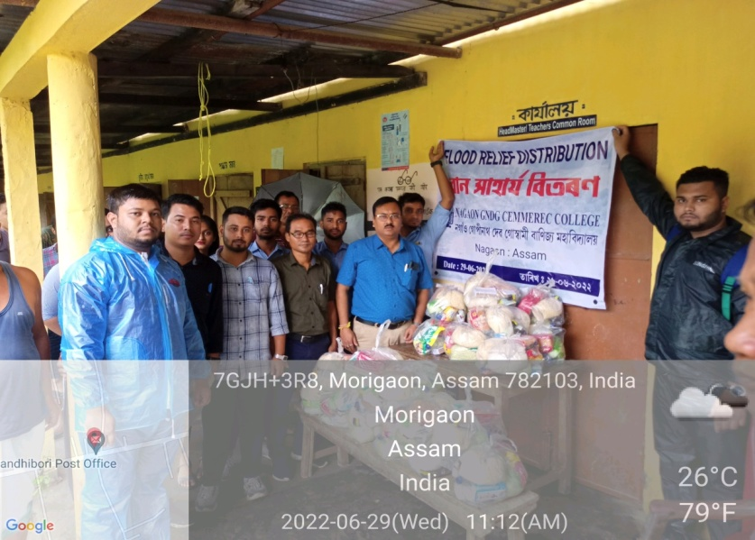
5.Number of VOLUNTEERS PRESENT 25.
6.TEACHERS PRESENT 5
7.NUMBE OF BENEFICIARIES 100.
PHOTOGRAPHS
MEDIA COVERAGE

